1. **What is the difference between Discrete and Continuous Data?**

Discrete data is a numerical type of data that includes whole, concrete numbers with specific and fixed data values determined by counting. Continuous data includes complex numbers and varying data values measured over a particular time interval.

1. **What is the criteria for data to land into dimensions and measures?**

Dimensions contain **qualitative/Categorical values (such as names, dates, or geographical data)**. You can use dimensions to categorize, segment, and reveal the details in your data. Dimensions affect the level of detail in the view.

Measures contain numeric, quantitative values that you can measure.

1. **What is Metadata, where is it present in the workbook?**

The Metadata API **enables you to see relationships between the content and asset that you're evaluating with other items on your Tableau Cloud site or Tableau Server**. These items include the following: Upstream and downstream content - including data sources, workbooks, sheets, fields, metrics, flows, and owners.

1. **What happens when you aggregate or disaggregate the Data?**

**Aggregate data combines and summarizes information, whereas disaggregate data separate aggregated data into separate points or pieces of information**. Disaggregating data might help gain a deeper understanding of various subsets within a larger dataset.

1. **You are working on a dataset, the client adds in more data to the dataset. What happens to the Visualization that you had created? Give the explanation for both Live and Extracted data.**

So, in the case of live connection whatever changes will be done at the Data source end that will be directly available to the tableau desktop. While in case of extracting any changes made in the data source won't reflect in the report immediately. **It will be reflected when the extract will be refreshed.**

1. **What are the file extensions in Tableau and how each one is different?**

* **Workbooks (.twb)** – Tableau workbook files have the .twb file extension. Workbooks hold one or more worksheets, plus zero or more dashboards and stories.
* **Bookmarks (.tbm)** – Tableau bookmark files have the .tbm file extension. Bookmarks contain a single worksheet and are an easy way to quickly share your work.
* **Packaged Workbooks (.twbx)** – Tableau packaged workbooks have the .twbx file extension. A packaged workbook is a single zip file that contains a workbook along with any supporting local file data and background images. This format is the best way to package your work for sharing with others who don’t have access to the original data.
* **Extract (.hyper or .tde)** – Depending on the version the extract was created in, Tableau extract files can have either the .hyper or .tde file extension. Extract files are a local copy of a subset or entire data set that you can use to share data with others, when you need to work offline, and improve performance.
* **Data Source (.tds)** – Tableau data source files have the .tds file extension. Data source files are shortcuts for quickly connecting to the original data that you use often. Data source files do not contain the actual data but rather the information necessary to connect to the actual data as well as any modifications you've made on top of the actual data such as changing default properties, creating calculated fields, adding groups, and so on.
* **Packaged Data Source (.tdsx)** – Tableau packaged data source files have the .tdsx file extension. A packaged data source is a zip file that contains the data source file (.tds) described above as well as any local file data such as extract files (.hyper or .tde), text files, Excel files, Access files, and local cube files. Use this format to create a single file that you can then share with others who may not have access to the original data stored locally on your computer.

**8. Filters:**

* What are the different types of filters and give their working order?
* Extract Filter.
* Data Source Filter.
* Context Filter.
* Dimension Filter.
* Measure Filter.
* Table Calculation Filter.

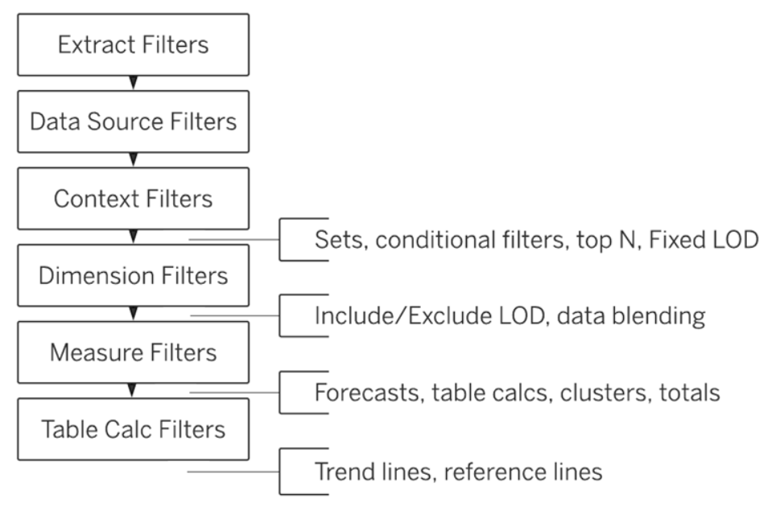

**6.5What are the variables that are considered to create the clusters by default?**

The variables which are similar in nature are grouped together in a cluster

**9. Dashboards & story:**

1. **What are the different device type preview that Dashboards can use?**

Default & Phone

Automatic, Fixed, Range

**11. Sets, Parameters, Groups:**

1. Parameters can be used in?

Parameters allow users to select or input a value. That value can then in turn be used in calculations, and subsequently, filters. You can even set the values that users can select to be automatically created from a field in your data, which saves time.

1. What are the different ways to create a Parameter?
   1. We can click on the drop down of data pane and click on ‘Create parameter ’ option
   2. We can right click on left pane and select ‘Create’ option and the select ‘Parameter’ option from the list.